Circle Language Spec: Inheritance

System Command Extension By Shadowing
You can accomplish command extension by employing the shadowing concept. The idea is that you shadow the base command, executing your own procedure and call the base command from your own procedure.

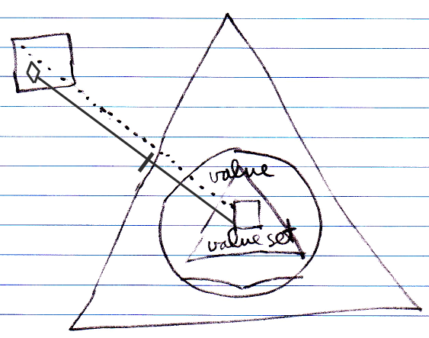

Note that the call to the base command has to be qualified with the base object.

When anyone tries to call Value Set, the shadowing command is run instead, unless someone can qualify the call with the base object.

A benefit of system command extension by shadowing compared to normal system command extension is that these extensions only count inside the derived class.

Author & Copyright: Jan-Joost van Zon Date: May 19, 2010 – July 16, 2010 Location: Oosterhout, The Netherlands Status: Finished

